## Partner contact info

Organization: T2 Software

Type: Industry/**SME**/Research/Academia

Name: Mustafa Sakalsız

e-mail: mustafa.sakalsiz@t2.com.tr

Phone #: +90 533 554 8434

## Partner interests within the project

<Please provide a short description of your R&D and collaboration interests and expectations within the OWE4SC project>

Company’s Information

T2 as an IT company, our focus areas are on smart city technologies and big data analysis. Billing which is only locally developed billing system used among big operator companies in Turkey, which processes 200.000 records per second with complex domain models and rules. Our billing capabilities can be used to monetize the usage IoT usage datas.

We developed several application frameworks and software infrastructure incorporated with Akbank, İş Bankası and Avivasa. Our company also has a product called Skykeeper based on social media analysis and tracking system running on cloud. We also executed a blockchain based projects including digital identity, smart contract, asset exchange and asset digitization entities with BKM, Turkish Exchange Bank. The biggest value of our companies is talented and loyal employees with enhanced R&D expertise.

Our target is to extend our vision and to gain more know-how based on Big data analytics and organizing smart city data by involving more global R&D based projects as well.

## Open Data and Technologies

<Please shortly identify and describe the relevant open data sets, data sources and open source technologies, which you see relevant in the project especially from your organization’s perspective. Please also describe related ecosystems.>

[www.kaggle.com](http://www.kaggle.com)

<https://www.drivendata.org/>

<http://mlr.cs.umass.edu/ml/datasets.html>

MapBox

MQTT

Google Cloud BigQuery

Google Cloud DataFlow

Python SciKit

HBase

Libraries in github related to smart buildings and smart environment

https://www.opendatanetwork.com/

NVIDIA, Open-Source Ecosystem Accelerate Data Science | NVIDIA Blog

## Success Factors/KPIs

<Please describe when you would see the project has been a success for you. Please identify and list relevant KPIs (Key Performance Indicators) from your organization’s viewpoint.>

Interoperability

* Time
* Content
* Cost
* Interoperability
* Security
* Velocity

## Background

Please list previous R&D projects you see relevant regarding OWE4SC project as background/collaboration possibility:

|  |  |  |  |  |
| --- | --- | --- | --- | --- |
| Project Name | Cooperative Programme | Time period (approx.) | Technical Focus | Relationship |
| Blockchain Technologies | <e.g. ITEA> | <2016-2018> | * Blockchain bringing security and transparency to record data is a distributed ledger technology. This distributed data technology ensuring data safety and immutability are applied in a wide range of domains fostered with cryptographic algorithms * Reconstructing all high cost business models like banking system relied on blockchain concept is discussed. The big corporates and companies have begun seeking and investing BC based platform solutions more. The aim of our project provides more secure, reliable, distributed open source application to their clients. | Greater control over own data, and how it can be used mitigates the potential risks sourced by smart home appliances usage. DLT has unique properties when it comes to inherent trust, immutable record keeping, shared computing power, and self-governing network. It provides all IoT-manufacturers a base network to run their own IoT network on, verify identities, and safely transact information. The missing glue that binds separated IoT networks with a communication bridge can be solved using DLT. |
| Mobile ad-hoc routing project |  | <2012-2015> | With advancement of (Mobile Ad Hoc Network-MANET application, establishing communication protocol between MANETs working on different platform needed. To serve this purpose, we begun implementing a back-end system providing end-to-end communication among MANETS working on different networks.  As result of that project main project consists of the components described below  Routing component among the fields and MANETs.   * Component associated with inter domain routing component * Component related to package dialing component * The component retrieving QoS request * The component choosing the route type based on QoS request.   The component choosing the route type based on policies | Within this project,  Communication protocols and interoperability between devices can be constructed as the basis of ROMAN project. Using MANETS in the projects enables energy saving and cost optimized solution due to gaining self-control on devices instead of centralized management and governance. Due to flexible and configurable structure, end users can set their own and compliances making the system usable and reliable. |
| Firefly Geometrics |  | <2018 – 2019> | Aggregation of car and display data from MQTT pub/sub system using Google Data Flow to Google BigQuery and BigTable systems.  Forming BigTable keys for optimized query of data.  Geographical visualization of high-density data.  Forecasting and optimization modelling. | Data infrastructure for collected data of the system. Organization and categorization IoT data. Forecasting usages of resources and wastes and optimizing their supply. |

Please indicate any relevant publications (scientific papers, white papers, etc), which you see relevant for the OWE4SC project as background information:

* <publication info, link>

Please indicate any relevant market study you see relevant for the OWE4SC project objectives:

* <publication info, link>

## Collaboration

<Please describe what kind of collaboration and networking benefits and added value your organization is looking for by participating the project. Please consider both business and technological viewpoint.>

We will begin improving our market potential across European continent. We will gain more insight with respect to IOT technologies supported with AI and Edge computing technologies as well as will deepen our expertise in BI and data analysis, methods and tools. In case of business viewpoint, we involve in more exploitation and dissemination activities which helps to extend our business network and seek for new business opportunities that maximize our mutual benefit and our reputation among our competitors. Donated with new technical expertise will reinforce our skill-set and talents provisioning more cutting-edge, innovative, and reliable enterprise for our clients.

## Outputs

<Please describe outputs (novel algorithms, standards, open source libraries, implemented collaborative framework, demonstrator, product prototype, new service based on some software, wearable device, etc.) that your organization can create/contribute to during the project.

* Adding IoT Monetization Features from our Billing Platform
* Routing and interoperability between IoT device networks based on our ROMAN project
* Big Data Layer for organizing IoT data
* BI reports
* Blockchain backend

## Role of the partner

<Please describe your envisioned role in the project and list the work packages you would like to participate - with work package specific description on your planned contribution>

WP3 - AI and Knowledge/Information/Data management

We have knowledge about data fusion and organization. We have capabilities to process high density data in short time with very scalable data processing architectures.

WP4 - Edge Computing and Communication, IoT and Digital Infrastructure

We can work on and optimize low bandwidth and wireless networks. Defining and implementing protocols stacks.

## Innovations and Standards

<Please list any relevant innovations and standards regarding the project from you organization perspective. Please identify any relevant standardization organizations that your organization is participating.>

* Blockchain Technologies (Distributed ledger technologies, loyalty programs)
* BI dashboards
* Big data technologies
* Data analysis

## Value chain positioning

<Please describe positioning of your organization in socio-cyber-physical value stream and markets illustrated in Figure 1 below>

**Relevant markets of the socio-cyber-physical value stream for my organization:**

* Edge Computing markets
* AI based markets
* Autonomic system markets
* Professional mobile application and services markets

**Positioning in the socio-cyber-physical value stream:**

<Please describe the added value your organization can bring within the value stream. What kind of organizations you envision as customers for your offering and on which markets? Which markets you need to participate and what kind of organizations you need to co-operate with to be able to provide your envisioned offering?>

As being Turkish consortium, our pilot studies and use cases will mainly focus on smart communities and smart buildings. Therefore, our targeted market will address :

* Smart Buildings Manufacturers
* Smart Buildings Distributors/Traders/Wholesalers
* Smart Buildings Subcomponent Manufacturers
* Industry Association
* Downstream Vendors

Innovating and developing smart technologies on the behalf of the communities gives rise to business network extension, introducing your products to new customer, gaining more reputation with your product among competitive market, enhancing business service quality and improving your brand value and eligibility compared to other companies, contributing to countries’ economical growth, social expansion and enrichment and social awareness towards technological advancement .

Using smart technologies in the cities and buildings contributes to economic growth and social impact in terms of the subjects mentioned below:

1. The global business network will be extended. Our production can motivate other groups to carry out more research and development based projects. Municipalities can be motivated to allocate more budgets on smart technologies and IOT based applications.
2. The interest rate of people working in construction and trading companies can increase against AI- and machine learning based systems.
3. Adding smart features in buildings will make people’s life easier and comfortable, as well as the security and safety in the environment can be ensured leading to increase their life span.

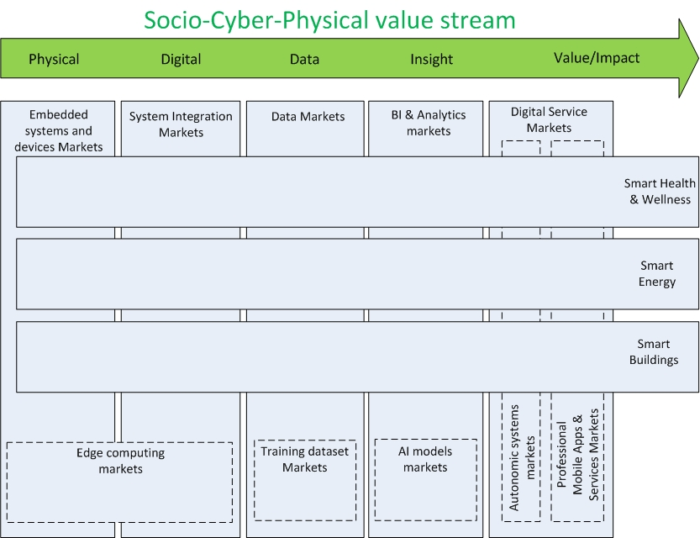

**Figure 1. Socio-Cyber-Physical value stream, related markets and application domains**.